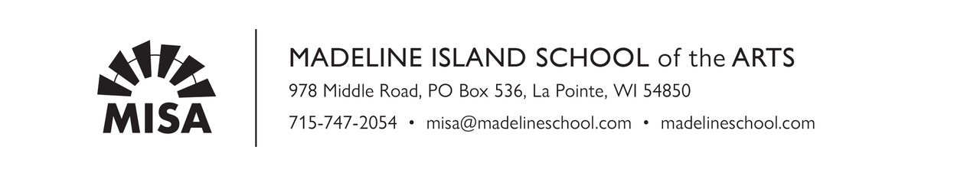
Astrophotography with Jason Weingart
Material List
- A sturdy tripod
- A DSLR or mirrorless camera with capability to shoot at least ISO 1600 with moderate to little noise.
- At least 2 batteries for your camera and a charger
- A wide angle lens of at least 24mm with an aperture of f/2.8 or less.
- Memory cards totaling at least 64 gigabytes
- Camera bag that can be easily carried
- Laptop with access to Adobe Creative Cloud (7 day free trial at Adobe.com) Photoshop, Lightroom
LRTimelapse
- Card Reader and/or USB cable
- An intervalometer
- Headlamp
- Folding chair or stool

