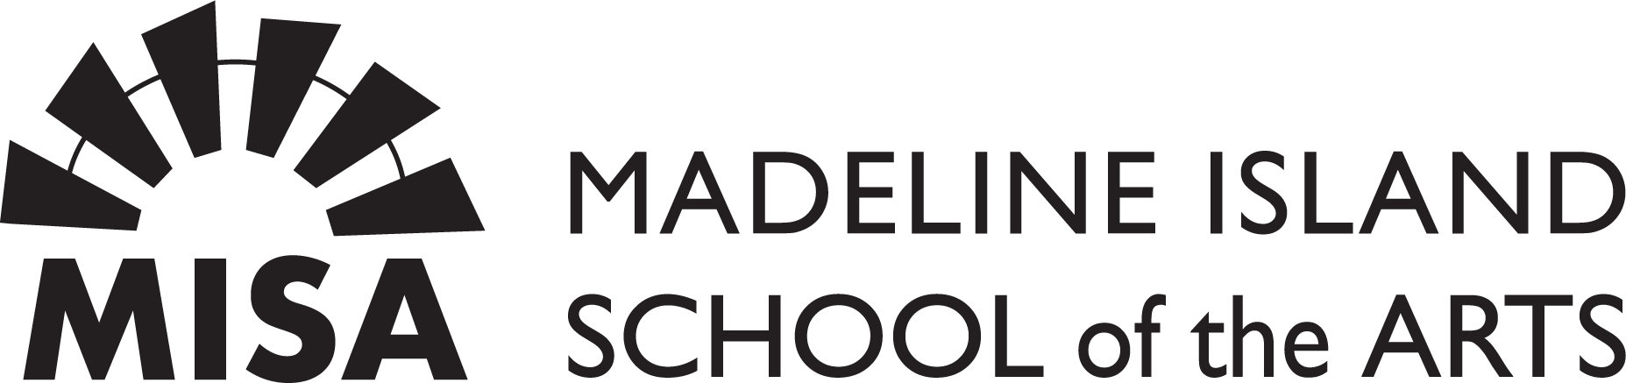

Where Watercolor Meets Nature: A Botanical Art Experience
Kristine Rapohina
Material list
Madeline Island Workshop

- Watercolor paper, hot pressed, at least 300gsm. Can be in block or sketchbook. Can bring both :)
- Watercolors, professional grade. You can bring what you already have. I will be using:
- Lemon Yellow (Schmincke)
- Indian Yellow (Schmincke)
- Transparent Yellow (Winsor&Newton)
- Sennelier Red (Sennelier)
- Alizarin Crimson (Schmincke)
- Permanent Rose (Winsor&Newton)
- Brilliant Purple (Schmincke)
- Manganese Violet (Schmincke)
- Perylene Maroon (Winsor&Newton)
- Perylene Violet (Winsor&Newton)
- Sap Gree (Winsor&Newton)
- Perylene Green (Winsor&Newton)
- Ultramarine Blue (Schmincke)
- Indigo (Winsor&Newton)
- Mixing palette – preferably ceramic palette or white dinner plate (ceramic, porcelain)
- Brushes – one fine tip brush N2 or N4 (depending on the brand, but it should be a very fine tip brush); round synthetic brush N7. You can have more brushes with which you are already working.
- Graphite pencils – 3H, 2H, HB, 2B, 4B
- Erasers – white dust free eraser, elastic eraser
- Ruler
- Masking fluid – optional
- Big mop brush (for removing erasing dust from the painting)
- Washi tape
- Water brush pen
- Ink marker 01, 02
- Any other art materials that you are using!

You can buy all art materials from www.kristineart.com/shop/art-materials
I can bring them to the workshop

